# **Solar Alliances**

*Game Design Document*

**Sofia Ferreira: 20200172**

**Leon Micheel-Sprenger: 20201117**

*Table of Contents*

1) Game Concept 2

1.1 Instant Summary 2

1.1 Game Story 2

Solar Alliances - *Expand your Horizon* 2

1.2 Overview 2

1.3 Inspiration 3

2) Game Mechanics 5

2.1 Core Gameplay 5

2.2 Types of Mechanics 5

2.3 Specifications 7

3) Interface 10

3.1 Main Interface 10

3.2 Solo Missions Interface 12

3.3 Joined Missions Interface 14

3.4 Shipyard Menu 18

3.5 Marketplace 19

3.6 Station Upgrade Interface 19

3.7 Choosing Factions 20

3.7.1 Mars 20

3.7.2 Earth 20

3.7.3 Belt 20

3.8 Login Screen 21

3.8.1 Create an account 21

3.8.2 Play with an existing account 21

4) Artwork 22

4.1 Style 22

4.2 Required Art 22

5) Sound and Music 23

5.1 Sound Effects 23

5.2 Music 23

6) Entity Relationship Model 24

# 1) Game Concept

## 1.1 Instant Summary

Solar Alliances is a resource management and strategy game. The player is the commander of a space station and can go on solo or multiplayer missions to accumulate resources and grow and expand his space station and fleet of spaceships.

## 1.2 Game Story

### Solar Alliances - *Expand your Horizon*

It is the year of 2350. Humankind has evolved and expanded its habitat across the solar system around the sun. While the best scientist and engineers are trying to terraform Mars into a habitable planet, many have ventured into the outer Asteroid belt and moons around Jupiter. Over time, separate political systems and organizations formed. Mars declared independence and became self-governing, while the Belt, scattered across different Asteroids, is still fighting for its freedom. Political interests, influence over resources and the development of new weapons brings humankind amidst a new Cold War between Earth (United Nations), Mars and the loose faction of the belt called OPA.

## 1.3 Overview

Solar Alliances lets you dive into this world of science fiction and factionism. The player is the commander of a space station associated to one of the factions (Earth/United Nations, Mars/MCRN, Belt/OPA) with a fleet of different kinds of spaceships. For the Vertical Slice, the scope will only hold the faction of Mars, which is to be extended in the full version of the game.

The player uses his/her fleet of spaceships to carry out single player and/or multiplayer **missions** to accumulate resources such as Water, Ore and Money. Resources can then be used to upgrade the players space station, build more and different kinds of ships and participate in larger multiplayer missions.

While there is no end goal for the player of Solar Alliances, he/she can level up his/her rank with the space station upgrades, which will unlock new ships to build, larger missions to be carried out and new levels of station upgrades to be available. While the vertical slice of the game will only consist of 3 levels to upgrade, the full version of the game will have more than 15 rank levels, which will constantly be updated with new types of missions, spaceships and space station upgrades, letting the game become more complex and decision intensive for the player. Also the full version will have upgrades for the existing ships, again intensifying the freedom of choice for the player.

Different decision trees will exist for the **space station upgrades** (3 levels included in the vertical slice) and the **ship upgrades** (not included in the vertical slice). An example of how such decision trees could look like is to be found below:

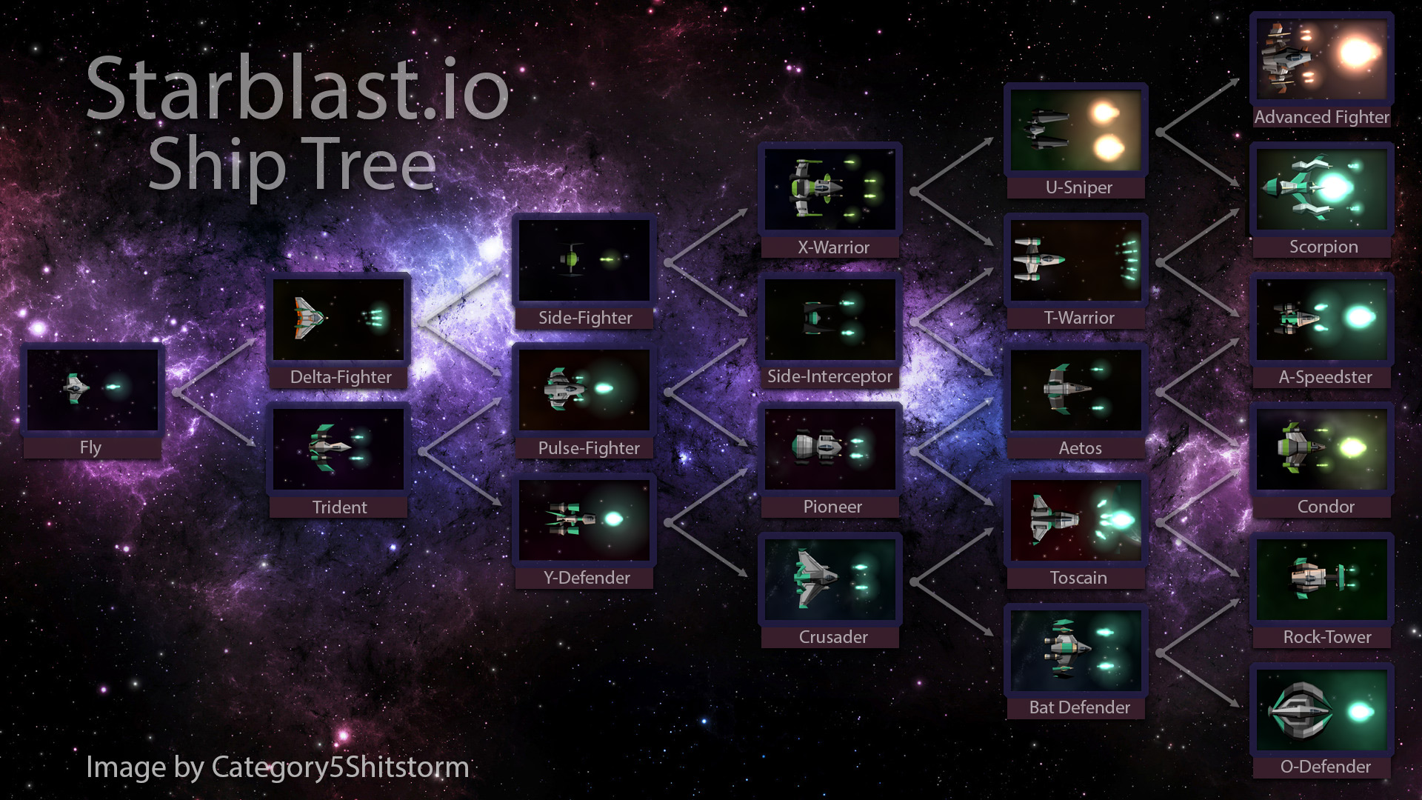

*(Sources: Starblast.io - image of Ship Tree)*

Solar Alliances is an online browser game, which can be played in single player and Multiplayer. In single player, Missions can be carried out alone, and in multiplayer, the players contribute to larger missions, which are only carried out, when certain resource thresholds are met.

The initial version of the game is a 2D Game without animations geared towards young teenagers (10-16).

The target audience is primarily male and interested in science fiction, astronomy and strategy games. While the persona of the target audience is interested in space world games (like eve online), he/she feels overwhelmed by the high complexities found in most of the available options and seeks an easy to play alternative to enjoy a similar game experience.

## 1.4 Inspiration

In the process of designing Solar Alliances, inspiration was drawn from different sources for the story and the game design itself.

For the story and concept of the game, the 2015 on Amazon Prime launched TV show “The Expanse” was the major inspiration. It creates the fundamental frame of the science fiction world, that Solar Alliances takes place in. The time, story and even factions are closely resembling the futuristic world of the Expanse.

As for the Game design and mechanics, different round based and real time Strategy games conveyed inspiration for Solar Alliances. Star Wars Empire at War was the major inspiration for the design of the main interface and core mechanics. Eve Online and Starblast were major inspirations for the space station upgrade concepts and level up process for the player. Finally, Civilization V provided some inspiration about decision-based strategies that were incorporated in the mission’s design of Solar Alliances.

# 2) Game Mechanics

## 2.1 Core Gameplay

After the player registers a choice of which faction to join needs to be made, which have its advantages, the Mars faction starts with 10% more money and the purchase of war ships will be cheaper, the other two factions will also have their advantages, but will not be featured during the vertical slice.

After choosing which faction to join the player will be taken to the game’s main screen. As the player progresses there will be decisions that need to be made, for example what station upgrade to do first or what ship to build, to do this the player will need to accumulate resources (people, ore, water and money).

To level up the player will need to complete one of the station's upgrades of the next level. Missions will depend on the level but collaborative missions will only depend on the faction that was chosen by the player.

## 2.2 Types of Mechanics

During the game the player will be able to:

|  |  |
| --- | --- |
| Build Ships | If the player has all the necessary resources and has unlocked that type of ship, in the station’s upgrades, he will be able to build that ship, the time to build the ship will be the same for all the ships of the same type but can vary between types (eg. war ship takes longer than transport ship). |
| Repair Ships | After the missions the ships may need to be repaired when that happens an icon will appear at the corner of the square where the ship is, after it appears the player just needs to click it and the ship will start the repair process, during that process the ship won’t be available for missions. |
| Do Solo Missions | The player will be able to do solo missions and there will be 5 missions available all the time but the mission at the end of the list disappears after 6 minutes and a new one will appear at the top of the list. the missions will depend on the level of the player. To do missions the player will need to spend some resources, the quantities will be set at random (so that the player can do the same mission more than 1 time without it feeling repetitive), the player will also need the type of ship required for that mission, the ship will be unavailable during the time of the mission, once the mission is over the ship will be available again and the player will receive the mission specific reward. |
| Do Collaborative Missions | For this type of mission, the player will only be able to join if he belongs to one of the factions that will be working on that mission and if the mission requirements for that mission aren’t fulfilled yet. Once the player opens the mission, he will be able to read a little about the mission, see what are the resources that were already submitted, the required resources, the reward that each player will get and the minimum contribution. After clicking in the button to contribute the player will then decide what he wants to submit, the submission will be rejected if the minimum contribution requirements aren’t fulfilled. After the mission requirements are fulfilled, the mission will start, the ship or ships will be unavailable once the player submits them for that mission. Once the mission finishes the player will be able to use the ship or ships that he sent again and will also receive the reward. |
| Upgrade the Station | The station upgrades are divided by level and by category, to do an upgrade of level 2 the player needs to have the upgrade of the same category of level 1 completed. There are 3 categories: the dome, that will increase the number of people that you can have on your station, the storage, that will let you store more ore and water, and the shipyard, that will unlock new types of ships that you can build or buy. The upgrades require money and will also take some time to be completed. |

## 2.3 Specifications

|  |  |  |
| --- | --- | --- |
| Resources | | |
|  | Money | Resource used to buy ships from the marketplace and to upgrade the station.  Receive as reward from collaborative missions and solo missions. |
|  | Ore | Resource used to build and repair ships and to do collaborative missions and normal missions.  Receive as reward from collaborative missions and solo missions. |
|  | Water | Resource used to repair ships and to do collaborative and normal missions.  Receive as reward from collaborative missions and solo missions. |
|  | People | Resource used to do collaborative and normal missions.  Receive as reward from collaborative missions and solo missions. |

|  |  |  |
| --- | --- | --- |
| Factions | | |
| latest (1446×904) | Earth/United Nations | Starts with 10% more people than other factions.  Transport ships are cheaper to buy and to build. |
|  | Mars | Starts with 10% more money than other factions.  War ships are cheaper to buy and to build. |
| latest (764×642) | Belt/OPA | Starts with 10% more water than the other factions.  Mining ships are faster to build. |

|  |  |  |
| --- | --- | --- |
| Station Upgrades | | |
|  | Dome | In this type of upgrade the player can increase the number of people that he can possibly store on the station. The first level of the dome upgrade lets you have 50 more people, the second level lets you have 100 more people and the third level will let you have 150 more people. |
|  | Storage | In this type of upgrade the player can increase the quantities of ore and water he can have in his station. The first level will let you have 50 more units of ore and water, the second level will let you have 100 more units of ore and water and the third level will let you have 150 more units of ore and water. |

|  |  |  |
| --- | --- | --- |
| Ships | | |
|  | War Ship | This ship is required to do war missions in either solo missions or collaborative missions.  **The player can hold many ships of the same type.** |
|  | Mining Ship | This ship is required to do mining missions in either solo missions or collaborative missions. |
|  | Transport Ship | This ship is required to do transporting missions in either solo missions or collaborative missions. |
|  | Exploration Ship | This ship is required to do exploration missions in either solo missions or collaborative missions. |

# 3) Interface

***Disclaimer:*** *The images of the interfaces below are intended to represent the location and functionalities in the game and are not a finalized version. The design of buttons, colors icons and images might differ drastically in the vertical slice of the game!*

## 3.1 Main Interface

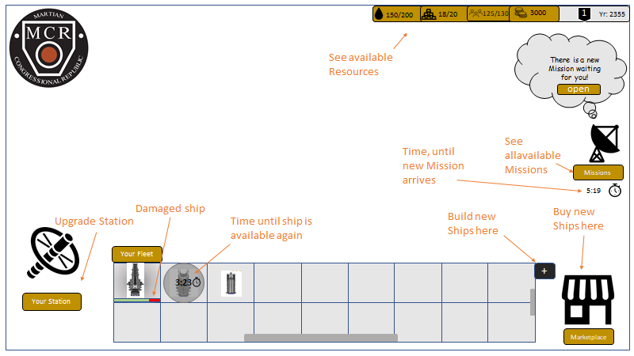

The main menu is where the player will have access to all the functionalities and sub interfaces that are required to play the game.

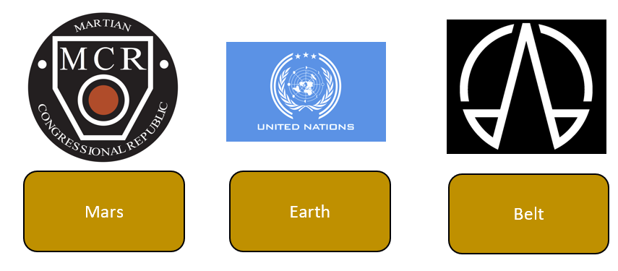

On the top left, an image will be shown, representing the faction, that the player belongs to. Mars, Earth and OPA/Belt. Choosing different factions has predefined benefits for the player and implications on the multiplayer missions (see 3.7 & 3.3). For the Vertical Slice of the Game, only the Martian Congressional Republic can be chosen as a faction, but the full version of the game will include all three factions.



On the top right (left to right), the player can at all times see his/her available **resources** as well as the **rank** of the player and the **Year**. Resources include Water, Ore, People/Workers (on the space station) and money. Water, Ore and People have a limited amount of storage available depending on the level of the space station storage upgrades. Money has no limit and can go up infinitely (i.e. an unachievable amount). The rank next to the money resource determines what missions will be randomly played out to the player. A player with a higher rank will get missions with different ships required and/or higher input resources and rewards. The player levels up the rank, when he/she achieves/buys a new space station upgrade. The year will go on at a speeded pace and has no functionality for the game.

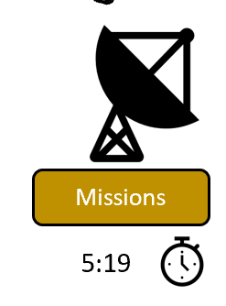

Below the resource bar on the right side of the main interface is the “Missions” icon and button. This is where the player can open the interface to display all available Single Player missions and browse a catalog of multiplayer missions (see 3.3). The vertical slice will show all the collaborative missions available to all players, but the full version will have a built-in filter to filter out the missions that are not relevant to the faction the player is in. Below the mission’s button is a timer, indicating when the next mission will be available to the player. (More on how missions work in 3.2 & 3.3 Missions Interfaces)

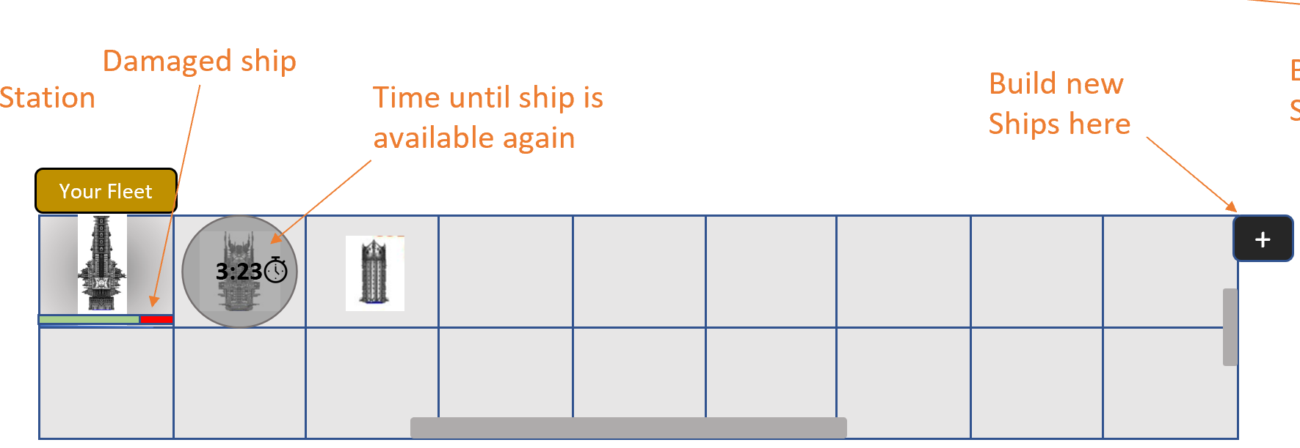

On the bottom in the middle screeching almost through the entire width of the screen is the fleet of the player to be found. Every player starts with 3 spaceships, that help him/her to carry out missions of all kinds. Each grey square represents one ship that the player holds in his/her fleet and that can be deployed to missions. When a ship is deployed for a mission, the ship will be greyed out (here with a circle shape) and a timer will be counting down, when the ship is available again, when it returned from the mission respectively. During this time, the ship is not available in the fleet and cannot be deployed on any mission. Ships can return damaged from certain missions (eg. war missions). In this case the “health” of the ship is reduced and it has to be repaired. The lost health will appear in a green/red health-bar representing how much percentage of health is left until the ship is destroyed. If the player doesn’t repair the ship and sends it on war missions for instance, it will at some point be destroyed and not return from the mission.

You can also access the interface of the shipyard by clicking the “+” symbol on the right of the fleet interface. There you can build new ships and repair damaged ships. (See 3.4 Shipyard Menu)



On the bottom right of the main interface is the Marketplace icon and button, which when clicked brings the player to the marketplace interface, where he/she can buy ships from the computer. (See 3.5 Marketplace)

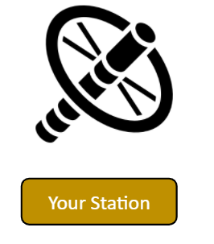

Finally, in the bottom left of the main interface is the Station icon and button, which brings the player to the Space Station Menu to make upgrades to his space station and by that level up his/her rank. (See 3.7 Station Upgrade Interface)

## 

## 3.2 Solo Missions Interface

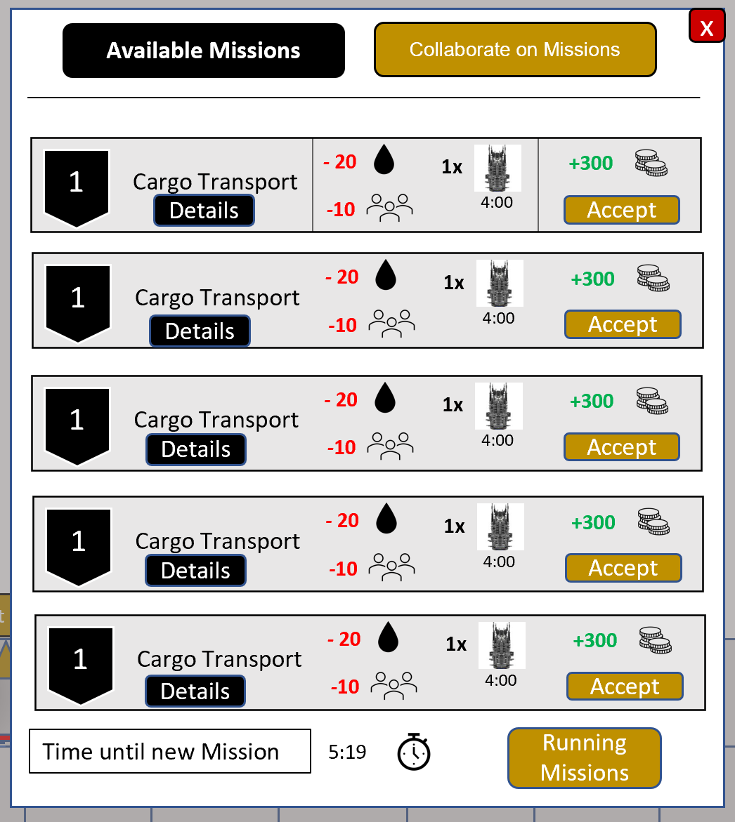

*(Depiction shows only one type and version of a mission for illustration purposes - Cargo Transport. In the vertical slice and the full game, the depicted missions will be different)*

The core of Solar Alliances single player gameplay is taking predefined missions, in order to deploy the fleet of spaceships and the gathered resources to expand the station and fleet of the player. Within the mission’s interface accessible through the mission’s icon on the main interface, the player will have access to both the available single player and multiplayer missions. The interface above depicts only the single player mission’s interface.

Missions are predefined challenges, that the player can accept or not accept when they appear in the mission’s menu. Each mission takes a certain amount of input resources (Water, People, Ore, Money) and needs ships to be deployed for a certain amount of time. In this example of a Cargo Transport, the player needs to invest 20 Water, 10 people and one transport ship, that is deployed for 4 minutes, in order to complete the mission and get the reward of 300 money. There will be different kinds of missions geared towards different focus points for the player. In the vertical slice of the game there will be war missions, transport missions, VIP transfers, Mining Missions, Espionage and Exploration missions. The full game will profit from a constantly updated database of different missions, that enhance the players choosing abilities and bring more complexity to the game.

Missions in single player appear every 6 minutes, meaning that this is when one new mission is added to the Top of the list, that the player can accept or leave. When a new mission arrives, the last mission in the list is then deleted, that is the player is leaving the mission. When the player accepts any of the missions, resources are deployed automatically and the mission is added to the list of Running missions, accessible through the button on the bottom of the solo mission’s interface.

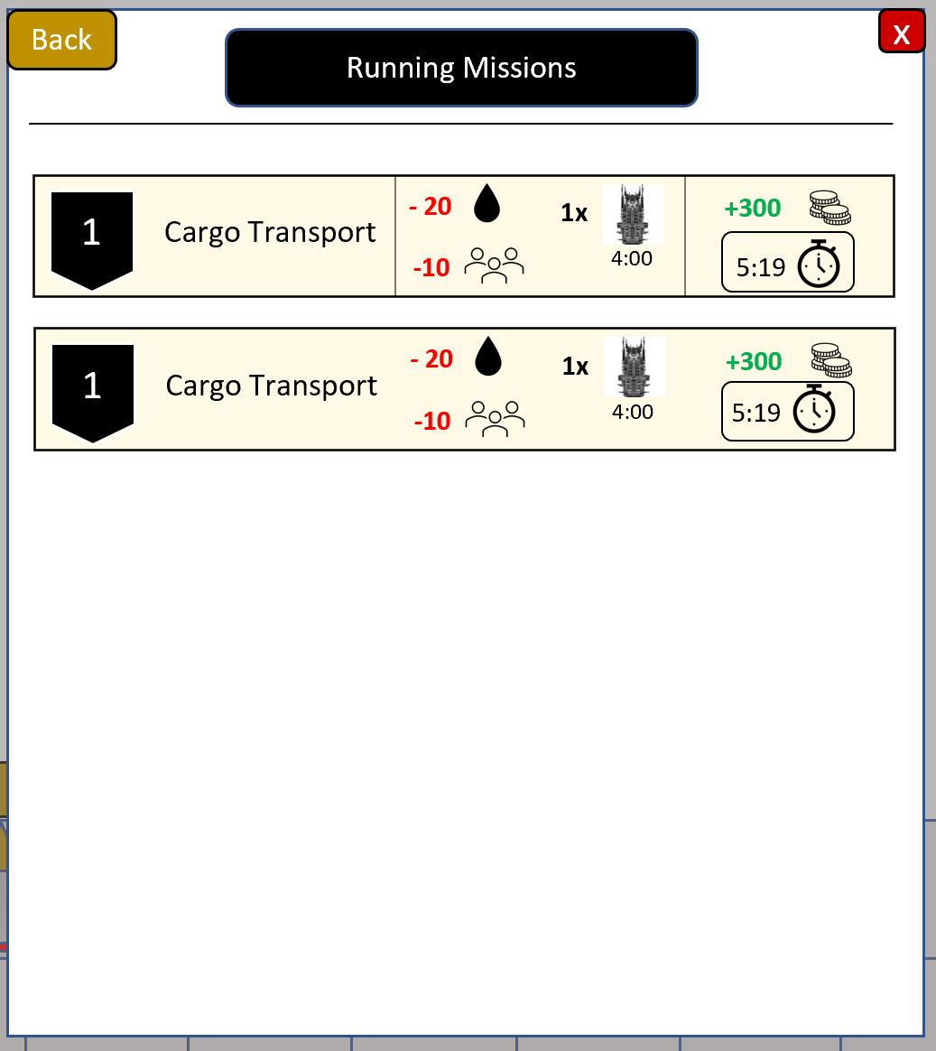

Missions are generated randomly from a list of types of missions. Within the mission types, the amount of required resources and the expected reward can vary significantly in individual missions. However, the missions are classified based on the level of the player. If the player is rank 1, he/she will only receive missions for that rank, that is the algorithm for generating the required resources, needed ships and expected rewards is generating numbers and types in another range than in another rank. That way, the player will be able to do bigger and more expensive missions, that require different kinds of ships when he levels up the rank by upgrading the space station.

## 

## 

## 

## 

## 3.3 Joined Missions Interface

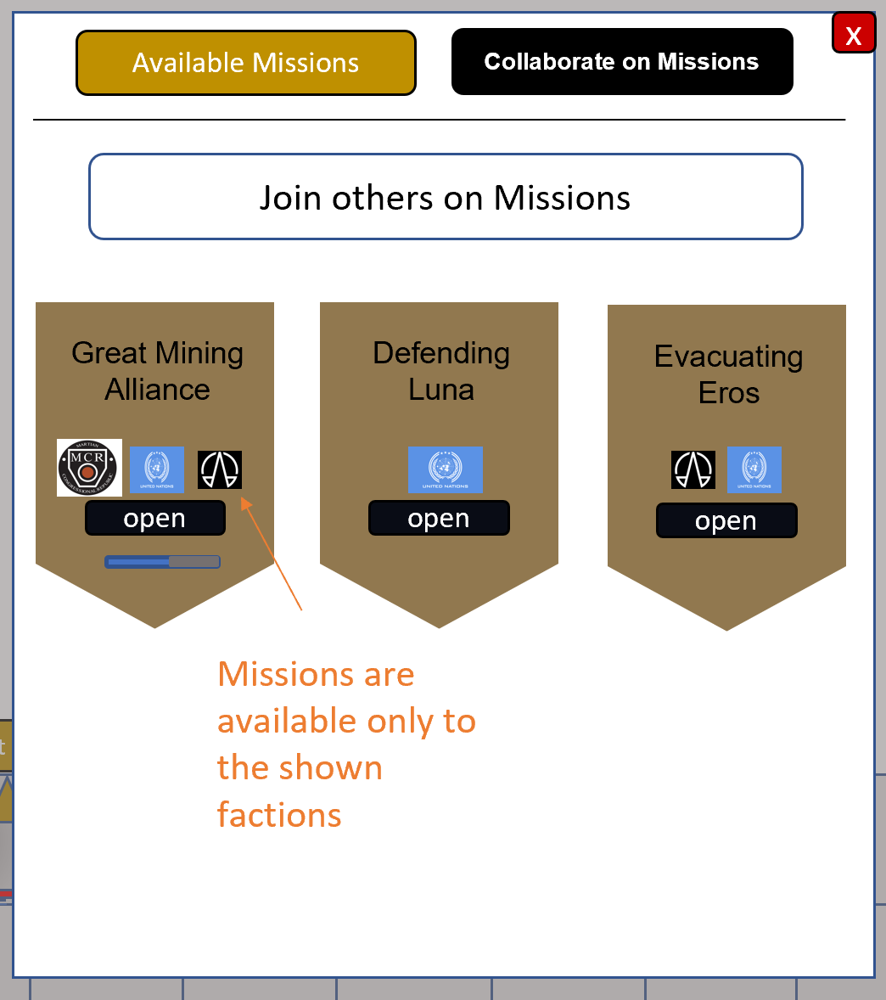

In the multiplayer mission’s interface, the player is able to collaborate with other players from different factions, which adds a collaborative team work pillar to Solar Alliances.

By clicking the “Collaborate on Missions” Button, the player will have access to all predefined multiplayer missions. Every card represents a separate mission. These missions have a greater story and are so resource intensive, that one single player could not do them. A blue status bar in the card shows the progress of how many percent of resources have already been contributed to this particular mission. Furthermore, the faction symbols tell the player, which missions are available to him/her. Players can only join on missions that are available to their respective faction, meaning they need to contain their faction symbol. The “Great Mining Alliance” mission in this example above has all three faction symbols and thus is available to all players. Since the vertical slice will only have one available faction (Mars), the vertical slice will only entail those collaborative missions available to mars. The full game will then have missions for all factions.

The multiplayer missions are created by the game developers, who will keep posting new exciting missions every week in the full version of the game. This allows the developers to integrate new features and extensions of the game into the collaborative missions as the extension and updates of the game progress. An initial amount of 100 multiplayer missions will be available at launch of the full version of the game. The vertical slice will entail between 2-5 actually playable missions for the proof of concept.

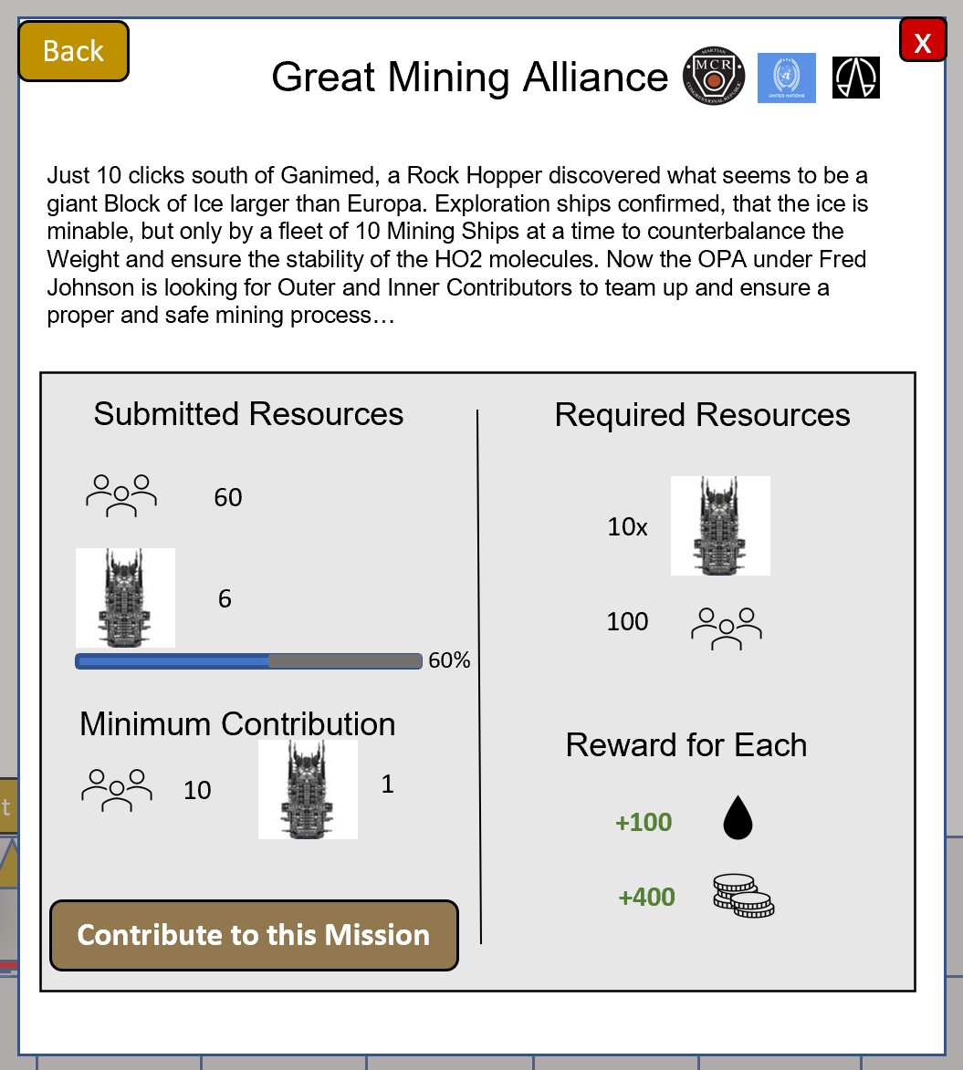

When a player opens one of the missions, the above menu will show. It entails a short background story on the top as well as information about the factions that are entitled to participate on this mission.

The right side of the tab shows the “**Required Resources**” that are needed to get this mission started. In this case it is 10 transport ships and 100 people. Players have to jointly contribute those resources to the mission, in order for the mission to start. On the left side, the “**Submitted Resources**” tell the player how many resources of the requirements have already been contributed to this mission. In this case, 60 people and 6 ships have been contributed by other players already, which is 60% of the total required resources. The “**Minimum Contribution**” tells the player how much he/she has to contribute at a minimum, to be a part of the mission and finally the “**Reward for Each**” shows what every contributing player will receive in return for his/her contribution to the mission, when it succeeds.

By pressing the Button “Contribute to this Mission”, the player will be shown to the following input mask:

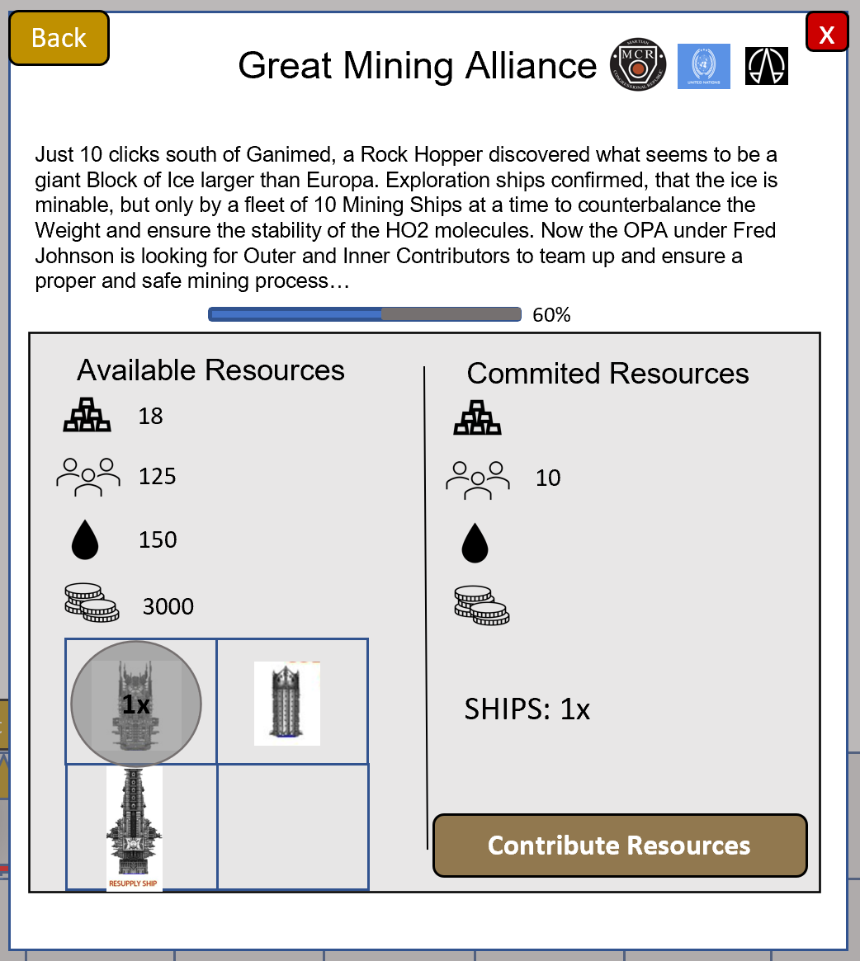

On the left side, the player can see all his available resources and his available fleet ships. Only those ships will be shown, that are currently available, not those that are out on missions. By clicking on each of the different resource icons, resources will be added to the right side’s “Committed Resources” (10 at a time for water, 5 at a time for people, and 2 at a time for ore). When ships are clicked, they are greyed out on the left side and only an amount of total ships selected will be shown on the right side Input Mask. When the player has checked his contribution, he/she can click “**Contribute Resources**” to submit the resources to the mission. Note, that resources will be deducted from the player immediately, even if the mission is not at 100% yet. Selected ships will be blocked for use, when committed to a multiplayer mission. This is to prevent missing resources, when the mission actually starts at 100% committed resources.

## 3.4 Shipyard Menu

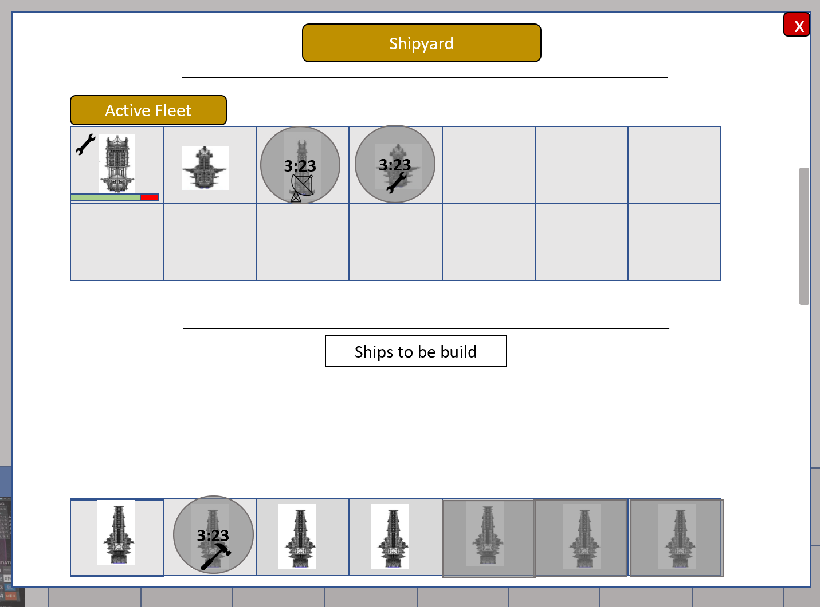

After clicking the Ships grid, the shipyard menu will pop up. The menu shows the currently active fleet, the busy fleet, as well as all ships that the player can still build. If a ship is damaged, then a health bar will appear right beneath the ship as well as a repair button. By clicking on that grid, a pop up will appear revealing the ship type, the repair cost and a confirmation button.

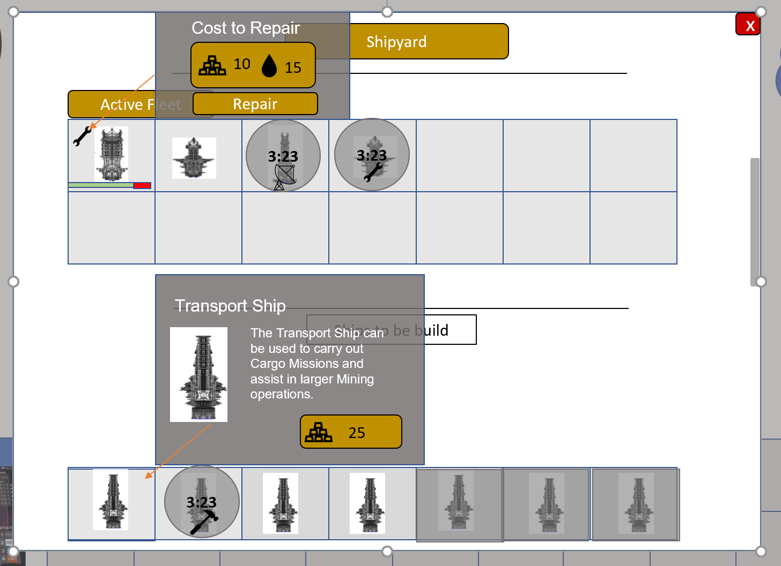

If a ship is being repaired, built or on a mission, then the grid will be darker and will have a time remaining until the mission is over marked in the middle in the format of hh: mm: ss.

## 3.5 Station Upgrade Interface

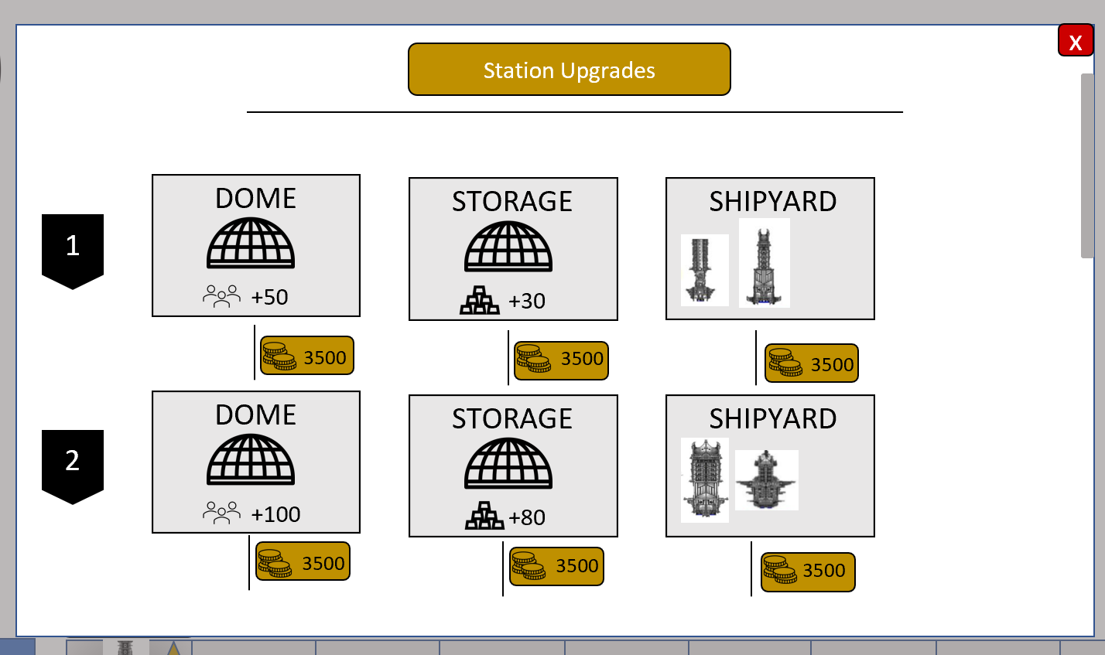

After clicking an icon that looks like a space station on the main menu, the player will be taken to the station upgrades menu. There players will be able to increase their maximum capacity of resources with their money. Upgrading the dome allows for more population to be on the space station, and hence a population capacity boost. Upgrading storages allows for more ores to be stored and thereby increasing the ore cap. Finally, the shipyard can be upgraded, this will allow for different ships to be built.

## 3.6 Choosing Factions

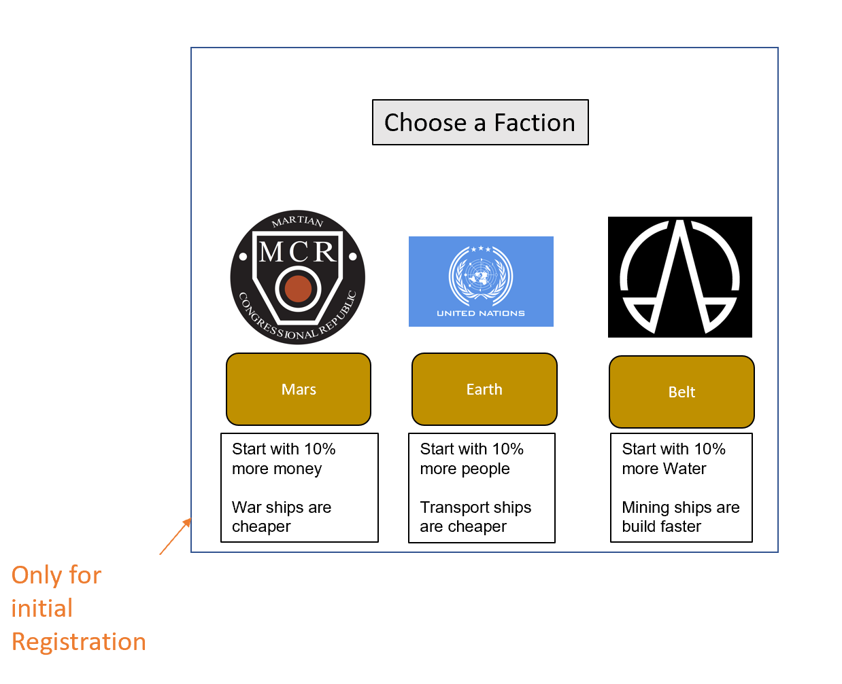

After creating an account, players are required to choose one of the three factions.

Each faction has its own ship's base design and technology. Due to that each faction has its own early advantage, and has an additional exclusive perk.

### 3.6.1 Mars

Wealthy faction. Starts with 10% more money than other factions. Due to being more invested in the military, all war ships are cheaper to build and to buy.

### 3.6.2 Earth

Impoverished and overpopulated faction. Starts with 10% more people than other factions. Transport ships are a lot cheaper to build and buy.

### 3.6.3 Belt

Most technologically advanced faction. Players who choose this faction will start with 10% more water and build mining ships a lot faster.

## 3.7 Login Screen

Once the player loads the game, he has 2 options:

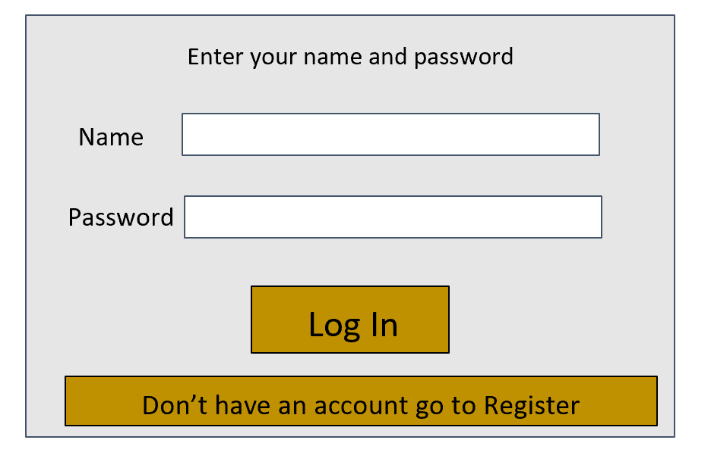

### 3.7.1 Create an account

The player is required to create an account before playing the game for the first time.

They will need to input their username, a password that won’t be accessible by anyone, the password again, which should be exactly the same to make sure the player put the correct password, input an email and check a box to confirm the player agrees with the developer’s terms of service in order to register.

The minimum password requirement is 6 characters.

If any step is missing, the player can’t click the “Register” button.

### 3.7.2 Play with an existing account

The player will simply need to input the username and the password of the account they wish to play on. In case the username or password doesn’t match, then an error will pop up asking them to try again.

# 4) Artwork

## 4.1 Style

The game art style is mostly simplified with simple icons that attempt to demonstrate the function of each button. Each faction will have its own background with the respective planet in the background. The Belt will have asteroid fields in the background. The background should represent the location of the player's space station with the images.

## 4.2 Required Art

List of all things, that require artwork:

* Ships
* Icons (list all different icons)
* Static Background
* Main menu
* Sign in/Sign up
* Marketplace icon
* Missions
* Co-op Missions
* Resources
* Game logo
* “Are you sure you want to do this action?” screen
* Background
* Faction logos
* Earth background
* Mars background
* Belt background

# 5) Sound and Music

## 5.1 Sound Effects

* Buttons clicked
* Getting and Accepting an offer
* Contribute Resources for joined mission button
* Start building a ship (hammer jamming on iron)

Feedback & Messages : (will be recorded by ourselves and put on a filter)

* + Welcome to the station Commander (when logged in)
  + “Welcome to the Shipyard Commander”
  + When Faction is chosen
  + Ship deployed for a mission
  + Ship has returned from a mission
  + Ship has been repaired
  + Ship needs repair
  + Ship repair has started
  + Ship has been destroyed
  + Ship has been build
  + Station Upgrade available
  + Station upgrade complete
  + Sound Effect for clicked button
  + New Mission available
  + Mission accepted
  + Mission is almost expired.
  + Your Contribution for a joined mission was successful.
  + Joined mission is deployed
  + Joined mission in completed
  + Player level up.(incl. Sound on level up)

## 5.2 Music

**-** Happy Jazz in the marketplace interface (inspo: Cantina Band)

- Background music for all other menus (spacelike) → subtle space background sound

# 6) Entity Relationship Model

**6.1 Entities and Attributes**

**Player**

The entity of the Player holds all information the player put in while creating an account: Name, Password and Email, as well as the player’s rank that can change throughout the game.

*Attributes:*

*Player_Id*

*Name: The name the player gave to his account. Always shown in the top left of the main U.I.*

*Email: Given by the player upon registration. Needs to input it to log in into the account.*

*Password: The password of the player’s account. Needs to write it every time the player wants to log in.*

*Rank: The player rank is dependent on the space station upgrades.*

*Faction_Id: faction id that the player is part (only 2 is available)*

*In_Game_Date: date in game*

**Player Resources**

The entity of Player Resources holds the information on the amounts of People, Money, Water and Ore the player holds.

*Attributes:*

*PResorces_Id*

*People: People are needed to complete missions, maximum capacity can be increased by upgrading the space station dome. More can be obtained by completing missions.*

*Money: Can be obtained from missions. Used to buy ships on the marketplace and upgrade the space station.*

*Water: Water is needed to complete missions, maximum capacity can be increased. More can be obtained by completing missions.*

*Ore: Ore are needed to complete missions, maximum capacity can be increased by upgrading the space station storage. More can be obtained by completing missions.*

*Max_People: maximum amount of people that can be stored.*

*Max_Ore: maximum amount of ore that can be stored.*

*Max_Water: maximum amount of water that can be stored.*

*Player_Id*

**Ship Fleet:**

The entity of the Ship Fleet holds all the ships that the player has available for missions. That means, the ships have been built or bought by the player and can be used. Ships in the ship fleet can be repaired if they are damaged from missions. That repairing will take place in the space station shipyard, which is why this entity needs to be joined.

*Attributes:*

*Ship_Fleet_ID*

*Ship_on_Mission: Defines, which ships that the player has are currently deployed on a singleplayer or multiplayer mission.*

*Ship_UnderRepair: Defines, which ships are under repair.*

*Ship_Health: Defines the health of each of the ships, that the player has in a percentage data point.*

*Ship_UnderConstruction: Defines, which ships are under construction*

*Player_Id*

*Spaceships_Id: To determine what ships does the player have.*

**Space station:**

This entity stores all the upgrades that were already completed by the player and assigns the rank to the player based on the upgrades made.

*Attributes:*

*SSUpgrade_Id*

*Upgrade_Type: Stores, which type of upgrade has been made (Domes, Ore/Water Storage, Shipyard Upgrade) (shipyard isn’t in the prototype).*

*Upgrade_Level: Stores, which type of upgrade has been made (Domes, Ore/Water Storage, Shipyard Upgrade.*

*Spaceships_Id: To determen what ships will be unlocked.*

*Price: price of the upgrades (money).*

*Increase_People: increase of max people on the station.*

*Increase_Water: increase of max water on the station.*

*Increase_Ore: increase of max ore on the station.*

**Spaceships:**

This entity stores all the spaceships that are available in the game. This includes available and unavailable ships for the player.

*Attributes:*

*Spaceships_Id*

*Type: The type defines what kind of ship it is. For the Vertical Slice, there are only 4 different types of spaceships; Warship, Transport ship, Mining ship, Exploration ship.*

*Time_Build: Time that takes to build the ships.*

*Time_Repair: Time that takes to repair the ships.*

*Price_Min: minimum price to buy the ship in the market (market not implemented in the prototype).*

*Price_Max: maximum price to buy the ship in the market (market not implemented in the prototype).*

*Input_Crew: people necessary to operate the ship (will be reduced from the people in resources).*

*Input_Ore: ore necessary to build the ship (will be reduced from the ore in resources).*

**Solo Missions:**

Solo Missions holds a list of all predefined missions that have input resources and output rewards. At all times a list of 5 available missions will be randomly generated for the player to choose from. When the player accepts the mission, the mission input resources will be deployed and after finishing the mission, the output reward will be granted to the player. On certain types of missions (eg. Combat Missions), the ships can get damaged and lose health. This damage will be randomly generated based on the mission and shown, when the ship is back from the mission.

*Attributes:*

*Solo_Missions_Id*

*Name: Name of the mission (eg. Cargo Transport Mission)*

*Story: Each Mission will have a small story attached to it.*

*Time: Time that the mission will last. This will also define how long a ship will be deployed and not available for the player to deploy on other missions.*

*Input_Money: Determines the amount of money that is required from the player to accept the mission. It is deducted from the players resources, when he/she accepts the mission.*

*Input_People: Determines the amount of people that is required from the player to accept the mission. It is deducted from the players resources, when he/she accepts the mission.*

*Input_Ore: Determines the amount of ore that is required from the player to accept the mission. It is deducted from the players resources, when he/she accepts the mission.*

*Input_Water: Determines the amount of money that is required from the player to accept the mission. It is deducted from the players resources, when he/she accepts the mission.*

*Ships_Id: The required ships to complete the mission. This will also define which ships will be blocked for use in the time of the mission running.*

*Reward_Money: Determines the amount of money that the player will receive after the mission finishes. It is added to the players resources.*

*Reward_People: Determines the amount of people that the player will receive after the mission finishes. It is added to the players resources.*

*Reward_Ore: Determines the amount of ore that the player will receive after the mission finishes. It is added to the players resources.*

*Reward_Water: Determines the amount of water that the player will receive after the mission finishes. It is added to the players resources.*

*Rank: Determines rank of the mission according to the player rank.*

**Multiplayer Missions:**

Multiplayer Missions holds a list of all predefined missions that have input resources and output rewards. The missions are accessible to all the players in the game. Players can contribute resources to the required resources of the missions. While making their contributions, players must submit at least a minimum requirement for the resources in order to be allowed to contribute to the mission. When a player makes a contribution to a multiplayer mission, resources are directly deducted from the players resources, even when the mission hasn’t been deployed yet. Multiplayer missions start, when 100% of the required resources are submitted to the mission.

*Attributes:*

*MMissions_Id*

*MMissions_Name: Name of the mission (eg. Great Mining Alliance)*

*Story: Each Mission will have a small story attached to it.*

*Time: Time that the mission will last. This will also define how long a ship will be deployed and not be available for the player to deploy on other missions. Starts, when the mission is starting, not when resources have been submitted.*

*Ship_Id: The required ships to complete the mission. This will also define which ships will be blocked for use in the time of the mission running.*

*Reward_Money: Determines the amount of money that the player will receive after the mission finishes. It is added to the players resources.*

*Reward_People: Determines the amount of people that the player will receive after the mission finishes. It is added to the players resources.*

*Reward_Ore: Determines the amount of ore that the player will receive after the mission finishes. It is added to the players resources.*

*Reward_Water: Determines the amount of water that the player will receive after the mission finishes. It is added to the players resources.*

*Input_Money: Determines the amount of money that is required from the player to accept the mission. It is deducted from the players resources, when he/she accepts the mission.*

*Input_People: Determines the amount of people that is required from the player to accept the mission. It is deducted from the players resources, when he/she accepts the mission.*

*Input_Ore: Determines the amount of ore that is required from the player to accept the mission. It is deducted from the players resources, when he/she accepts the mission.*

*Input_Water: Determines the amount of money that is required from the player to accept the mission. It is deducted from the players resources, when he/she accepts the mission.*

*Ship_amount: Amount of ships needed for the missions.*

*Minimum_Money: Determines the minimum amount of money that is required from the player to accept the mission. It is deducted from the players resources, when he/she accepts the mission.*

*Minimum_People: Determines the minimum amount of people that is required from the player to accept the mission. It is deducted from the players resources, when he/she accepts the mission.*

*Minimum_Ore: Determines the minimum amount of ore that is required from the player to accept the mission. It is deducted from the players resources, when he/she accepts the mission.*

*Minimum_Water: Determines the minimum amount of money that is required from the player to accept the mission. It is deducted from the players resources, when he/she accepts the mission.*

*Minimum Contribution: Determines the amount of resources that a player needs to contribute in order to participate in the mission.*

**Computer Trading:**

The trading market holds a list of all the available ships that the player can buy with their defined respective prices. On the marketplace, the player is able to buy all types of ships at all times (not just those that are unlocked). Prices are associated to the existing spaceships in the entity “spaceships”

*Attributes:*

*Trading_Id*

*Spaceships_Id: To determine what ship the player is buying.*

**Player Upgrades:**

The player Upgrades holds theupgrades done by the players.

*Attributes:*

*Id*

*Player_Id: Defines which player did the upgrade.*

*SSUpgrade_Is: Defines which upgrade was done.*

**Factions:**

This entity stores all the factions that are available in the game as well as their benefits.

*Attributes:*

*Faction_Id*

*Faction_Name: Name of the factions.*

**Accepted Solo Missions:**

This entity stores all the accepted solo missions that the player is doing or was completed in the game as well as the ship that went on the mission and the time to finish the mission.

*Attributes:*

*asm_Id*

*Player_Id: Player that is doing or did the mission.*

*Solo_Mission_Id: Solo mission that is being done or was been done.*

*Mission_Time: Time to complete the mission (if it is at 0 the mission was been completed).*

*Ship_Fleet_ID: Ship that is or went on the mission.*

*Confirmation_Sent_To_Player: confirmation that the mission was been completed (if 0 the mission isn’t completed, if 1 the mission is completed).*

**Player Missions:**

This entity stores all the missions that are available to the player.

*Attributes:*

*Player_Mission_Id*

*Player_Id: Player that has the missions avaiable.*

*Mission1: Mission that appears to the player.*

*Mission2: Mission that appears to the player.*

*Mission3: Mission that appears to the player.*

*Mission4: Mission that appears to the player.*

*Mission5: Mission that appears to the player.*

*RespawnMissionTime: Time until a mission respawns.*

**Submited MMissions:**

This entity stores all the submitted things to a multiplayer mission.

*Attributes:*

*SubmittedMission_Id*

*Submited_water: Water submitted to the mission.*

*Submited_people: People submitted to the mission.*

*Submited_ore: Ore submitted to the mission.*

*Submited_money: Money submitted to the mission.*

*Submited_ships: Nº of ships submitted to the mission.*

**6.2 Entity Relationship Model**

